Contents
1. Introduction 2
2. Resources included 2
3. Testing steps 2

Introduction
This document contains information that helps you to test and validate functionalities an Access Point Provider's needs to support the GST InvoiceNow Requirement.
This test suite is designed based on specifications and functions detailed in TX1 and TX3. Users should be familiar with the above TX1 and TX3 documents and have completed development of the required functionalities before proceeding with this test suite.
The AP GST InvoiceNow modules being tested are:
- Peppol B2B Delivery
- Invoice Data submission
- Frontend service
- Whitelist management
- Reports
- [Recommended] Validation Check for Wrongful GST Charges

Resources included
  - 1. START HERE.docx
This document.
  - 2. C5 Accreditation Testing - AP.xlsx
Test script details. For each test script you will find the setup, expected system behaviour and required supporting evidence.
  - 3. IMDA AP C5 Testing Report [AP Name].docx
This is the report template to be provided for verification of your testing.
  - 4. xml examples (folder)
Template xml files to be used for testing cases. See 3.1 Test preparation section below on how to use these files.
  - 5. SP Reporting Template_Jan_2026_v2.2
Monthly report template for TC601
  - 6. non_peppol_doc_validation.sch
Validation schematron for non Peppol documents
  - 7. non_peppol_doc_validation.xsl
Validation schematron for non Peppol documents (stylesheet format).
  - 8. TESTING_ONLY_NOT_FOR_PROD.sch
Used for TC302 to bypass local validation

Testing steps
3.1 Test preparation
- Review the test script detailed in C5 Accreditation Testing - AP.xlsx
- Prepare XML payload based on templates provided in the xml examples folder following below instructions:

- Replace the Peppol ID with the actual Peppol ID that was used for C5 activation ( i.e. same ID used in test case TC101), also replace the company GSTN and UEN to match the Peppol ID
In the SBDH:

In the payload:
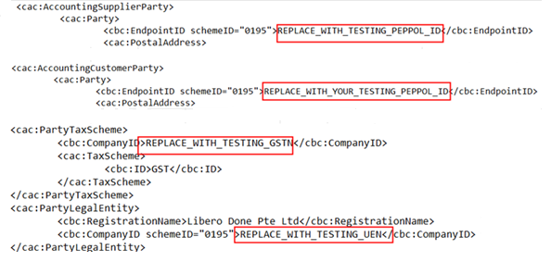
- Generate your own transmission UUID and replace the transmission UUID in the SBDH. If you need a tool to generate UUIDs, you may consider this online tool https://www.uuidgenerator.net/
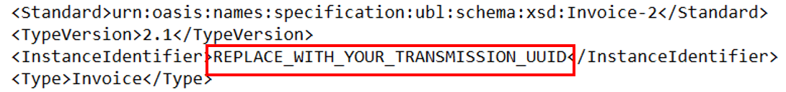

- Generate your own Doc UUID and replace the doc UUID in the XML. Note that this Doc UUID is repeated in the SBDH for all Non Peppol documents
In SBDH:
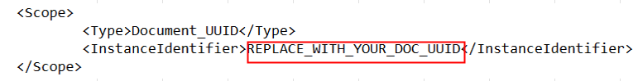
In payload:


NOTE:
Do not use the provided file without updating as instructed above.
For APs who ingest non-XML format from their customer (e.g. JSON in API payload), after updating the sample XML file, please convert the content in the XML file into your own required format for frontend interface ingestion for each of the test cases.

- A special testing UEN and Corppass id is required to complete this set of tests. Please contact einvoice@imda.gov.sg to request a testing UEN and Corppass id prior to your testing.

3.2 Test execution
- Follow test scripts detailed in C5 Accreditation Testing - AP.xlsx to execute the test cases one by one, and gather the required evidence as detailed in column G.
- Ensure all mandatory test cases are completed successfully and required evidence captured.

NOTE:

All GST InvoiceNow testing should be carried out in the IMDA/IRAS sandbox environment/API. Sending test invoices to IRAS production system is not allowed.

3.3 Report submission

- Ensure the completeness and accuracy when including required screenshot(s) to show all specified data fields and IDs of all the Sub Test Cases.
- Rename the IMDA AP C5 Testing Report [AP Name].docx to include your company name e.g. IMDA AP C5 Testing Report [ABC Company Pte Ltd].docx.
- Submit the complete test report to einvoice@imda.gov.sg with the email subject (GST InvoiceNow Test Report – [AP Name]). If you wish to include the evidence of each Sub Test Cases outside of the test report, make sure the screenshot(s) is named according to the identity of the Sub Test Cases (if you have multiple screenshots distinguish them with an extension such as ‘_1, _2, _3, etc in sequence) and please do consider compressing them into a password-protected zip file.
- If the attachment is over the size limit of email, please split the attachment into multiple password-protected zip files to send in separate emails with '_1', '_2', '_3', etc. in sequence.

